Name: Math Lesson 1.6 September 29, 2014
Graphing Relations
In both examples, continue the pattern and complete the chart. Do you notice a pattern grow ?
Describe the relation in words: ____________________________________________________________________
Describe the relation as an algebraic expression:
________________________________
Describe the relation as an algebraic equation : __________________________________
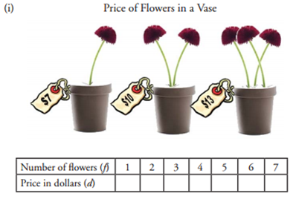

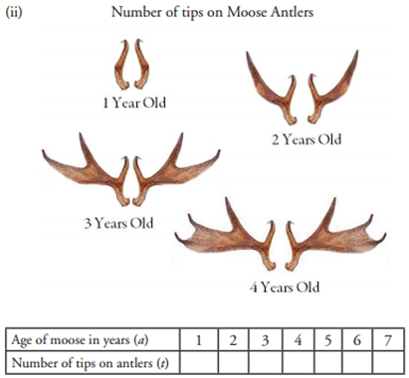
Describe the relation in words: ____________________________________________________________________
Describe the relation as an algebraic expression:
________________________________
Describe the relation as an algebraic equation : __________________________________
When you have completed the charts and relations, graph both examples. Be sure to:
- label the axes - indicate the scale on the axes - give the graph a title - plot point accurately
